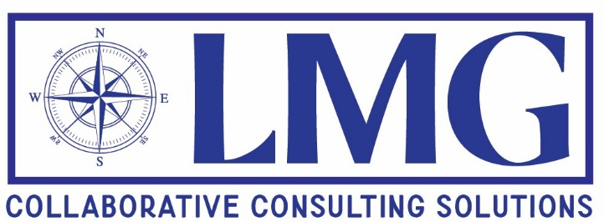
Lisa M. Gomez
lisamgomez@lmg-ccs.com
917-757-5100

Lisa is the founding member of LMG Collaborative Consulting Solutions, a firm providing comprehensive public policy and other consulting services in all aspects of employee benefits, including compliance, plan administration, plan design, advocacy, communications, government agency engagement, and strategic planning. In this new chapter, Lisa seeks to partner with employers and other plan sponsors and administrators, labor organizations, service providers, and worker advocates and use her experience and voice to help them successfully achieve their goals. Lisa can also serve as a professional trustee or independent fiduciary, expert witness, arbitrator, or mediator.
Lisa was nominated by President Joseph R. Biden as Assistant Secretary of Labor for Employee Benefits Security for the U.S. Department of Labor in July 2021 and was confirmed by the U.S. Senate in September 2022. She was sworn in by Secretary of Labor Martin J. Walsh on October 11, 2022, and served in that position until January 20, 2025. Previously, Lisa was a long-standing partner with the law firm Cohen, Weiss and Simon LLP, representing labor organizations and employee benefit plan sponsors and administrators, and the chair of the firm’s management committee.
Lisa has deep technical and practical experience in the multifaceted field of employee benefits law and has spent almost three decades representing various Taft-Hartley and multiemployer pension and welfare plans, single employer plans, jointly administered training program trust funds, a federal employees health benefit (FEHB) plan, supplemental health plans and voluntary employee benefits associations (VEBAs) covering workers in a wide array of industries. As the head of the Department of Labor’s Employee Benefits Security Administration (EBSA), Lisa was responsible for leading an agency with approximately 850 full-time employees nationwide and a budget of approximately $191 million and was charged with the safeguarding of the job-based retirement, health and other welfare benefits for more than 153 million American workers and retirees and their families. Through Lisa’s leadership, EBSA had regulatory and enforcement authority over approximately 2.6 million job-based health plans, 801,000 retirement plans, and over 600,000 other welfare plans, with combined assets of nearly $12 trillion, in addition to the oversight of the federal Thrift Savings Program, the largest defined contribution program with approximately seven million participants. In this position, Lisa worked closely with the White House’s Domestic Policy Council, National Economic Council. Gender Policy Council, and top advisors to the President and Vice-President, as well as leadership with other federal and state agencies, members of Congress and external stakeholders. Lisa was recognized for her work with the agency during her tenure, including in areas such as retirement security, implementation of SECURE and SECURE 2.0, the No Surprises Act, the Mental Health Parity and Addiction Equity Act, the Employee Ownership Initiative and other projects and priorities. Lisa was a frequent speaker during her time at EBSA, appeared in several webcasts, podcasts, and other media interviews, and continues to be sought by the press and in public speaking roles as a recognized thought leader in employee benefits.
Prior to her time in public service, Lisa served as a co-chair of the board of senior editors of the Bloomberg BNA treatise Employee Benefits Law. She also served in various leadership positions with the American Bar Association (ABA) Section of Labor and Employment Law, including as the union co-chair of its employee benefits committee, and continues to be a member of that committee. She is a graduate of the ABA Section of Labor and Employment Law’s leadership development program and served as the union co-chair for that program. She is a member of the International Foundation of Employee Benefit Plans and the AFL-CIO Union Lawyers Alliance. Lisa was inducted as a Fellow of The American College of Employee Benefits Counsel, Inc. in recognition of her decades of practice in employee benefits law and her contributions to the field, and now serves on its Board of Governors as well as Chair of its Social Media Committee. Lisa was also a member of the advisory board of The Peggy Browning Fund. She previously served as an arbitrator for the American Arbitration Association as well as a volunteer mediator for the New Jersey state courts. She has been a guest lecturer for the Cornell University School of Industrial and Labor Relations, Drexel University School of Law and Hofstra University School of Law on employee benefits. Lisa was named as a Super Lawyer for Employee Benefits on the Super Lawyers New York Metro Annual Lists for 2021 and 2022. She earned her law degree from the Fordham University School of Law and her undergraduate degree from Hofstra University.
Lisa is also the Chair of the Board of Harbor of Hope of New Jersey, a non-profit organization serving the immigrant and LGBTQIA+ communities, and those living with or recovering from domestic violence and mental health issues. Lisa is the Treasurer and Vice-Chair of the Employee Ownership Expansion Network (EOX), a non-profit organization dedicated to the promotion of all forms of employee ownership in the U.S. She is also a member of the Advisory Board of Cover My Mental Health, a non-profit dedicated to assisting those living with mental health conditions in getting access to care. Lisa lives in New Jersey with her husband and their three adult children.

