Katrina Veldkamp

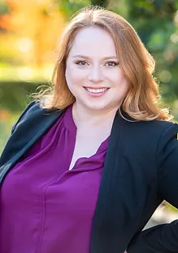
Katrina has employee benefits in her blood – many of her relatives have worked in retirement plan administration
– but she is the first ERISA attorney in the family. Katrina enjoys working through and solving the puzzle of employee benefits with her clients.
Over the course of her career, Katrina has advised both private and public sector clients on issues related to employee benefits, with a particular focus on retirement and health plan compliance, mergers and acquisitions, and the drafting, operation, and design of all types of retirement plans.

Katrina also advises and counsels clients regarding nonqualified deferred compensation plans.
Katrina advises clients on health and welfare issues such as HIPAA, COBRA, Section 125, and the Affordable Care Act, and has extensive experience drafting health and welfare plan documents, communications, and policies. She also counsel clients on fiduciary concerns under ERISA and applicable state and local laws.
​
Katrina has represented clients before the Internal Revenue Service, the United States Department of Labor, the Pension Benefit Guaranty Corporation, and the California Public Employees' Retirement System.
In her free time, Katrina is an avid reader and singer. She is on the Board of Directors of the Orange County Women’s Chorus.
​
Representative Speeches and Publications
“Expanded EPCRS and Determination Letters.” Veldkamp, Katrina and Fay, Alison. Western Pension & Benefits
Council Orange County Chapter Technical Lunch, August 2019
“ERISA for Non-ERISA Lawyers.” Veldkamp, Katrina and Kravitz, Ronald. Orange County Bar Association Labor
and Employment Law Symposium, June 2019
“COBRA Compliance-Still Relevant in 2018!” Boutwell, Sherrie and Veldkamp, Katrina. Journal of Pension
Benefits, vol. 26, no. 2, 2019
​
Admitted:
2012, California, United States Tax Court, the U.S. Ninth Circuit Court of Appeals, and the U.S. District Court for the Central District of California, 2012
​
Education:
University of California, Los Angeles, J.D., 2012
University of California, Los Angeles, B.A., 2008
​
Memberships :
Orange County Bar Association
State Bar of California, Tax Section
Western Pension & Benefits Council, Orange County Chapter
​
Leadership:
Board Member, Orange County Women’s Chorus

